- QIP Alert Trigger Conditions
The QIP system will automatically trigger an alert when one of the following conditions is met:
Molding Department:
- 5 identical defects within 1 hour
- Defect rate ≥ 10%
- Shoe Defect Type C
- Shoe Defect Type B
Sewing Department:
- 5 identical defects within 1 hour
- Defect rate ≥ 15%
- Shoe Defect Type C
- Shoe Defect Type B
When any of the above conditions occurs, the system will automatically trigger an alert.
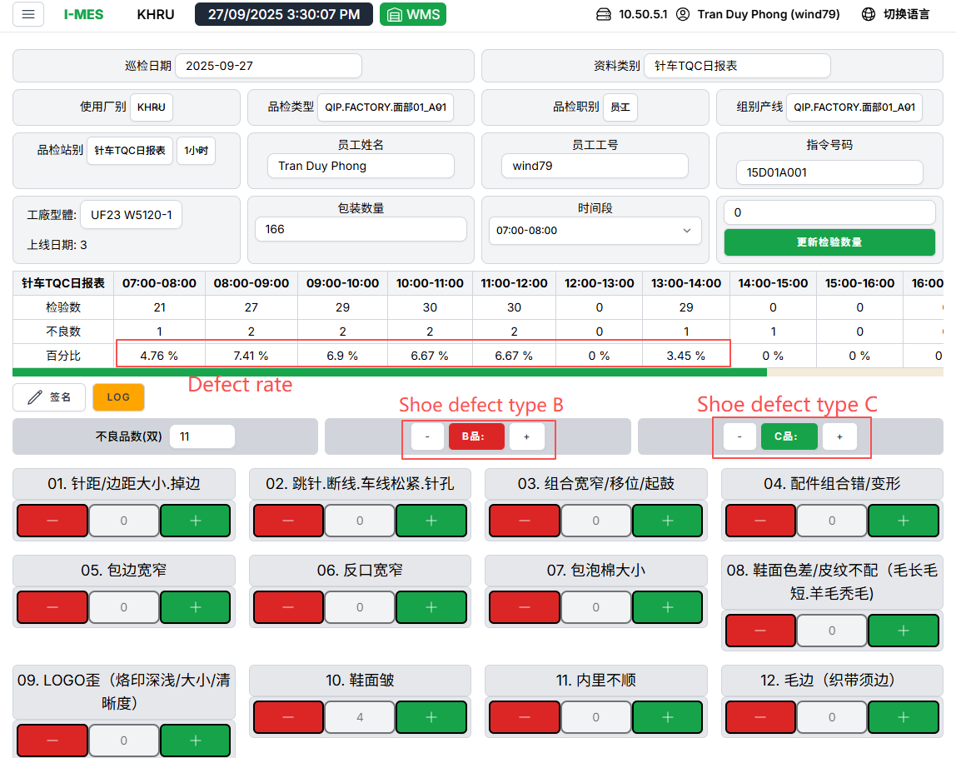

- Display Warning On Screen
When an alert is triggered, a notification will be displayed on the screen as follows:
Image of a red light and a "關閉" button
Notes:
- Red Light: Indicates that the alert status is active.
- "關閉" (Close) Button: The button used to start the alert handling process.
- The external device will play sound

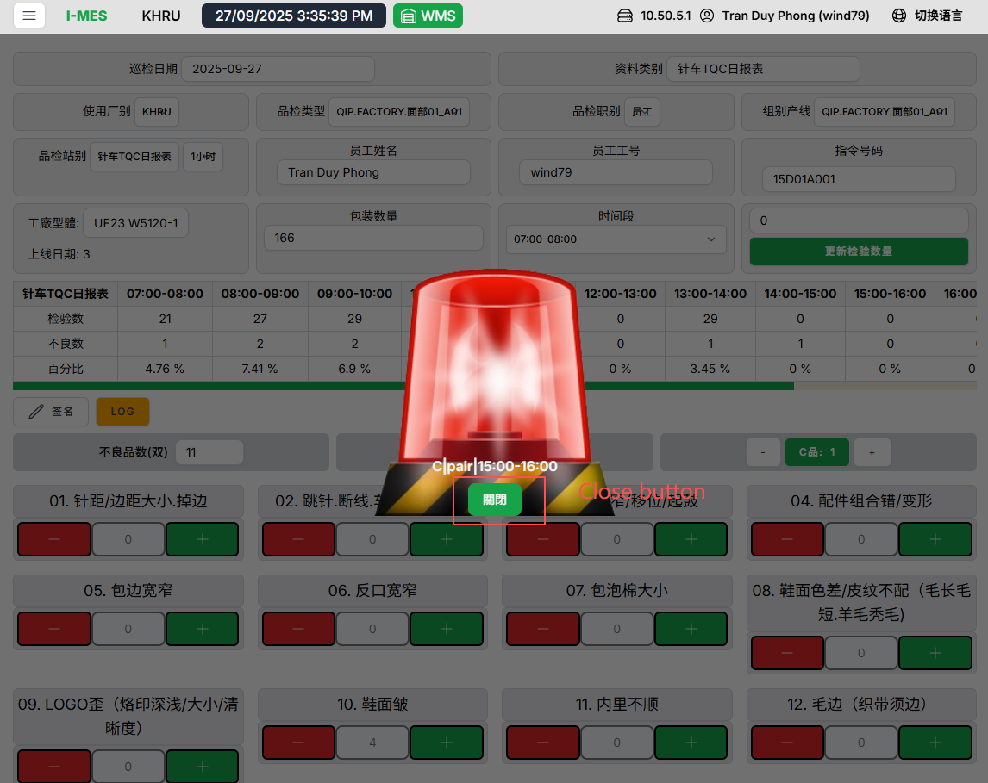

- Warning Handling Procedure
To handle the alert, please follow these steps:
Step 1: Press the "關閉" (Close) Button
Click the "關閉" (Close) button on the alert screen.

Step 2: Sign for Confirmation (Popup)
After pressing the "關閉" button, a popup window will appear requesting a signature for confirmation.
Please sign in the confirmation box.
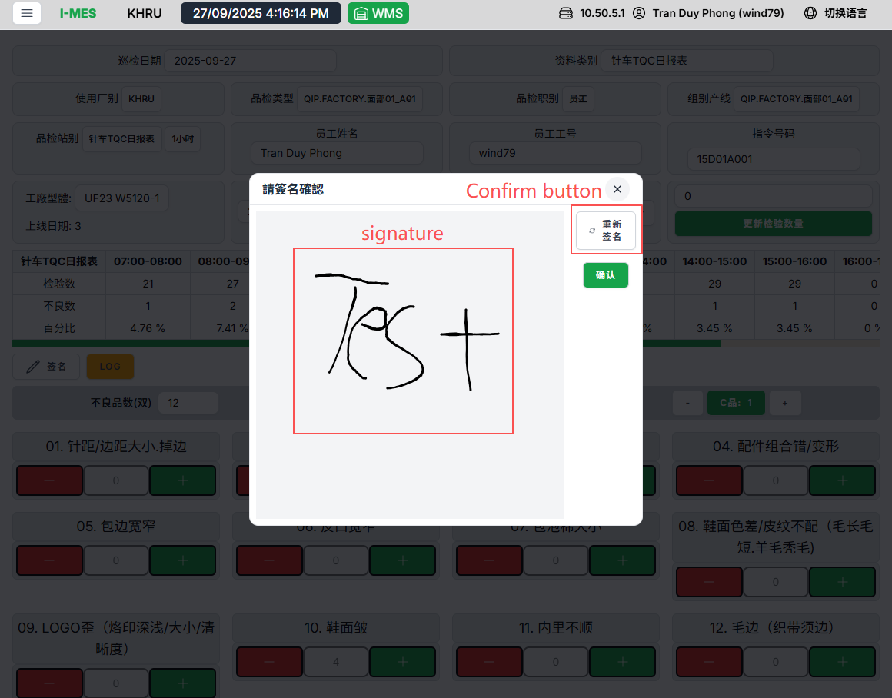
Step 3: Successful Confirmation Notification
After signing successfully, a notification will appear confirming that the process has been completed.
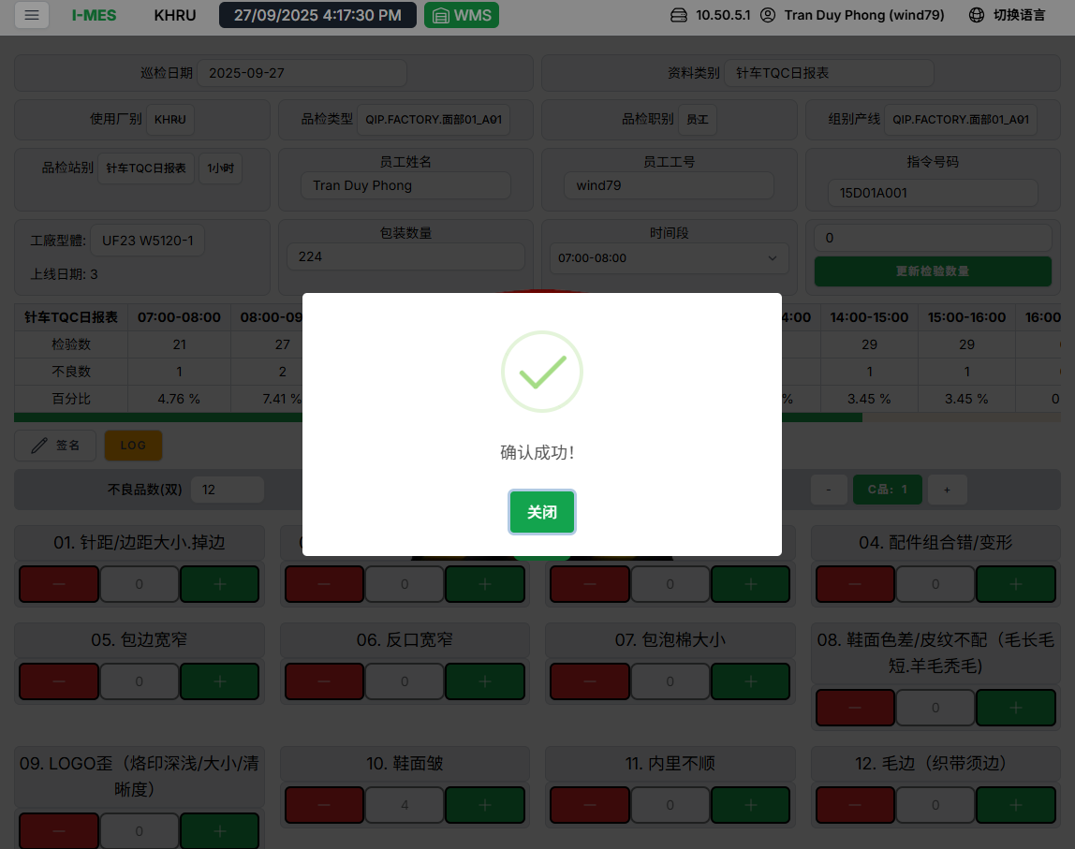
Step 4: Alert Stops
Once the confirmation process is complete, the red alert light and sound will turn off, indicating that the alert has been handled.
Note: After the alert stops, it is necessary to investigate the cause of the alert and implement appropriate corrective actions.

